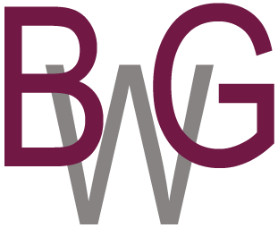
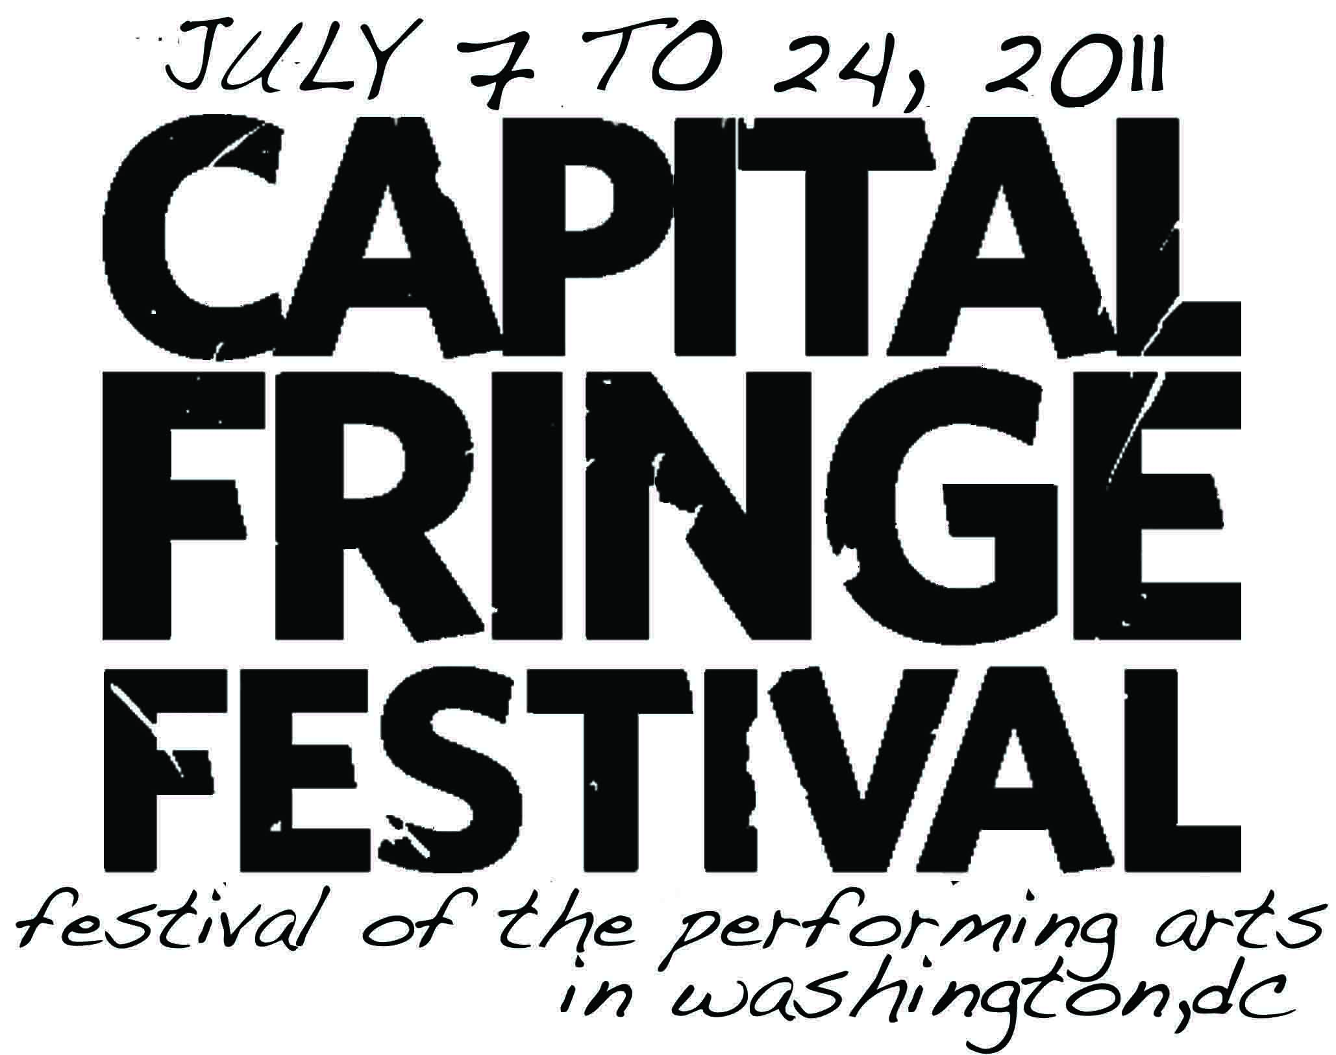

For Immediate Release
June 23, 2011
Media Contact:
Lisa A. Shenkle
VERB! Communications
410.439.4695

A Day at the Museum, to Participate in the Capital Fringe Festival, Marries Nudity, Art and Ensemble Mime to Music, July 7 - 24, 2011

Washington, D.C. - Nudity, comedy, art and music are the recipe for this Capital Fringe confection entitled A Day at the Museum where a wordless cast cleverly creates the characters, and their personas, while visiting a museum gallery to view a series of three paintings.
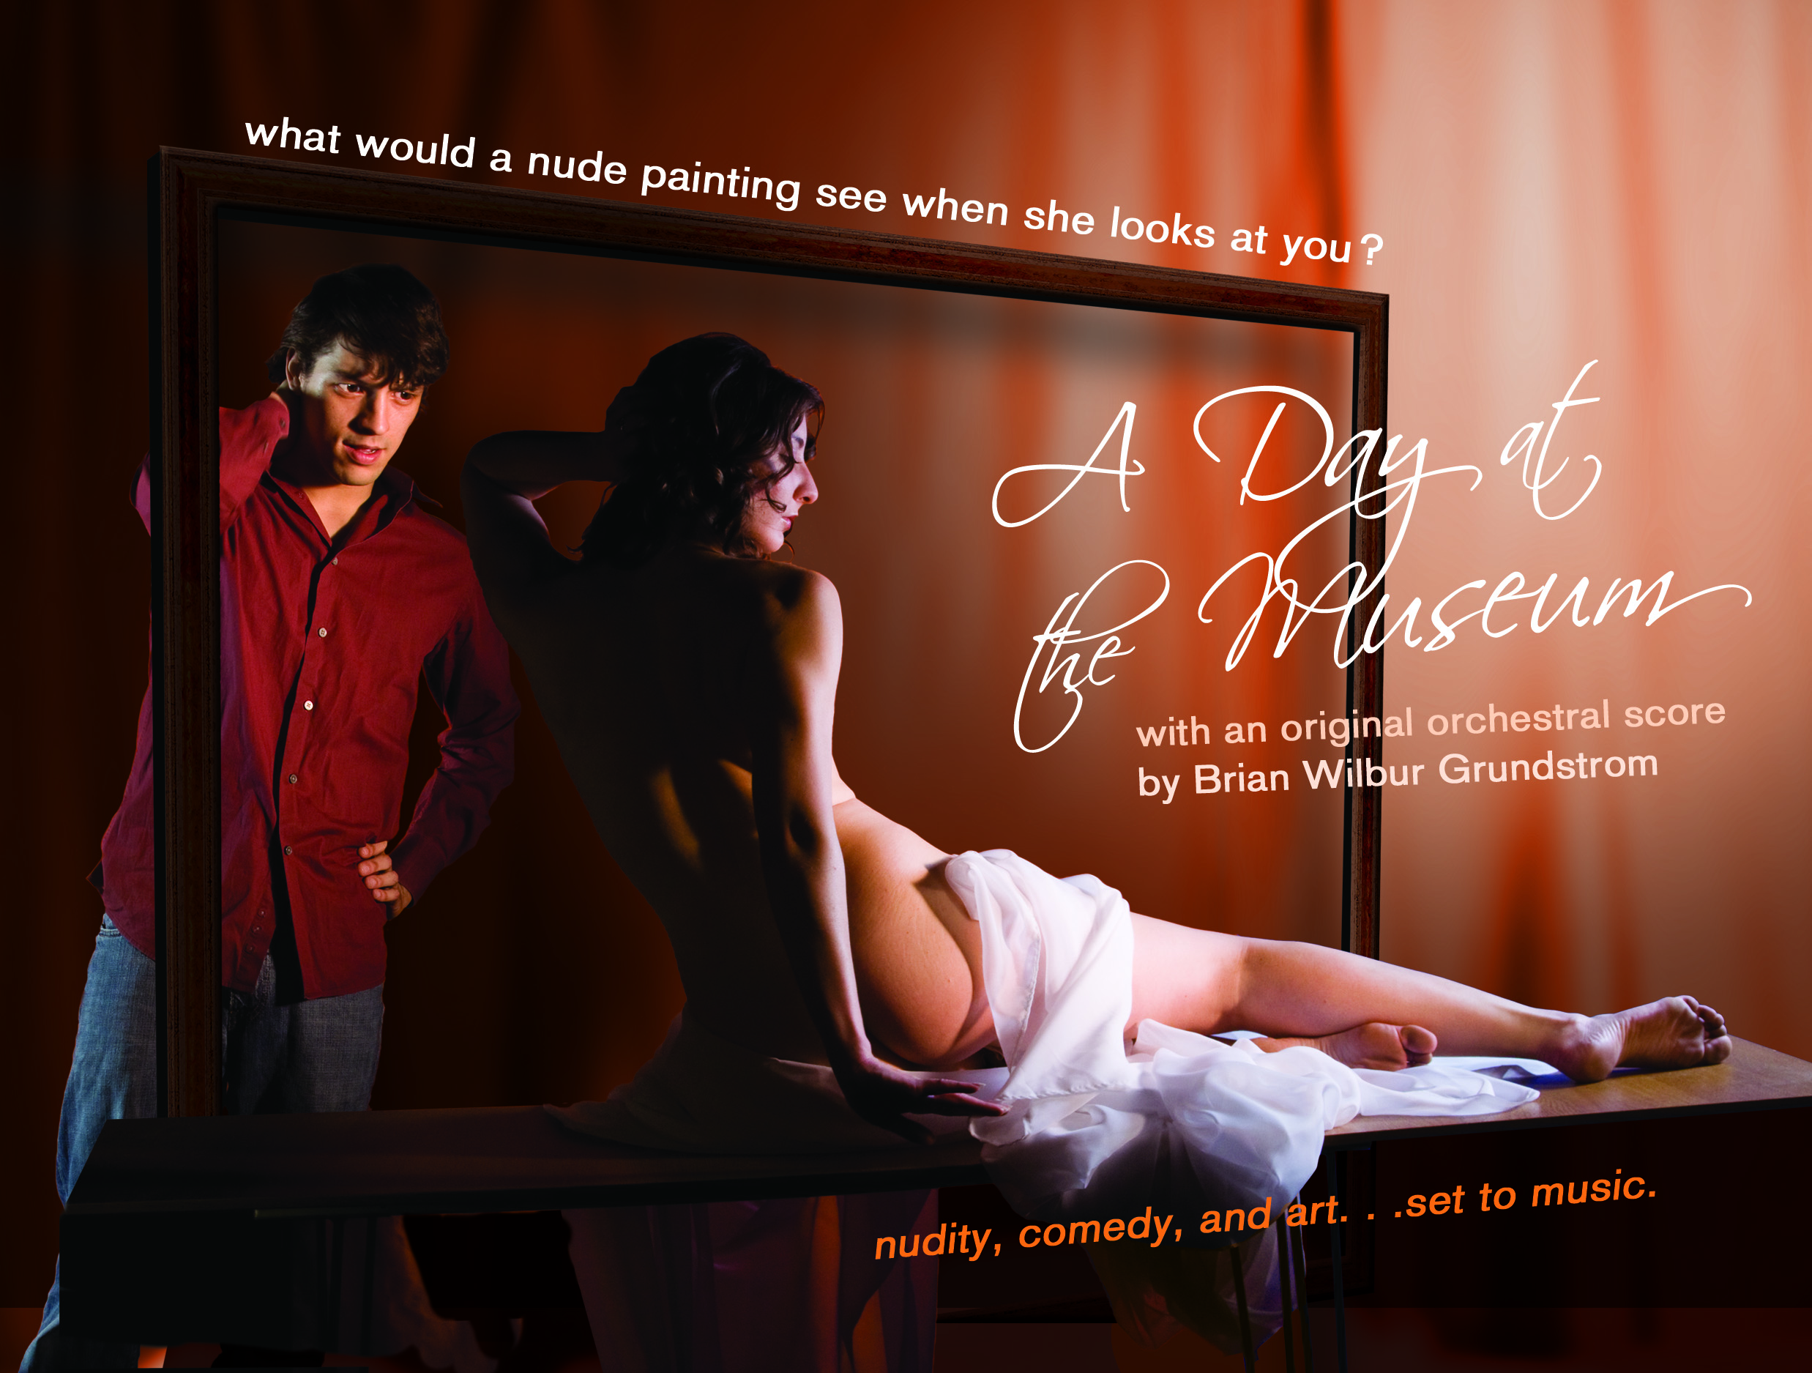
This play by Robert Barnett is an ensemble mime piece set to an original score by award-winning composer Brian Wilbur Grundstrom. This is Grundstrom’s second score to be featured at the Capital Fringe Festival. In 2010, Grundstrom was nominated for his work on the musical score to Pepe! The Mail Order Monkey Musical, which sold out in the 2009 Capital Fringe Festival.
In A Day at the Museum, the cast creates a montage of quick-changes, dynamic interactions and emotional exchanges in this visual fugue. The centerpiece of the play is that of three paintings which capture the essence of a single woman at various stages in her life from innocence and motherhood to empowered sexuality a la the nude. This same woman, older now, visits the museum with her adult daughter to reveal the paintings to her.
Perspective, misperceptions and comedic interactions of the museum visitors, centerpieces themselves, capture the essence of transitions, the central theme of the play.
Grundstrom’s music is essential to the production: the music conveys a full gamut of emotions, and challenges the actors to properly reflect these same emotions in their gestures.
“A Day at the Museum is unique in that the entire vehicle for moving the play is the music,” says Brian Wilbur Grundstrom. “While the cast is ‘wordless’ the music sets the tone, pace and cadence for their interactions, emotions and timing.”
The cast includes Loren Bray, Jonathan A. Douglas, Doug Krentzlin, Sunshine, Kathleen Mason, John Milosich, Pamela Nash, Ryan Sellers and Susan Holliday who is nominated for her supporting actress role in the indie short film "Plus One" by the World Music and Independent Film Festival (WMIFF).

What: | A Day at the Museum  Warehouse  645 New York Ave., NW @ 7th Street  Washington, DC 20001  Sunday, July 10, 6:30 PM  Friday, July 15, 10 PM  Saturday, July 16, 7PM  Wednesday, July 20, 10:15 PM  Saturday, July 23, 2:15 PM
Where:
When:

Fringe Festival  Press Contacts:  Fringe Festival  Press Page: | Lauren Gross, 202.265.5383, c: 202.255.2054 laura@capitalfringe.org  Ebony Dumas, 202.737.7230, communications@capitalfringe.org  To view Press Release and images from this show online at capitalfringe.org or http://www.brianwilbur.com/ADayAtTheMuseum/index.asp
Tickets for A Day a the Museum are available directly at Fort Fringe & the Baldacchino Gypsy Tent Bar, 607 NEW YORK AVE. NW WDC 20001, call 866.811.4111 or go to www.capitalfringe.org. Tickets are $17 each; a $7 Fringe Festival button is also required for admittance.

About A Day at the Museum
Composer Brian Wilbur Grundstrom collaborated with playwright Robert Barnett in 2008 to write the work, which was premiered in the New York International Fringe Festival with director Ed Wierzbicki.
In this DC premiere directed by Perry Schwartz, Grundstrom is also wearing the hat of producer. This production is presented as a part of the 2011 Capital Fringe Festival, a program of the Washington, DC non-profit Capital Fringe.

About Brian Wilbur Grundstrom
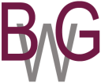
Brian Wilbur Grundstrom’s compositions for film, orchestra, musical theater, chorus, piano, and chamber ensembles demonstrate an innovative use of harmony and melody, which, although firmly rooted in the tonal tradition, is entirely new. Audiences take to his compositions immediately, finding in his compositions traces of Aaron Copland, Kurt Weill and Samuel Barber. His awards include Encore from American Composers Forum, ASCAPLUS from ASCAP and Composers Assistance Program from the American Music Center. He received three grants from the D.C. Commission on the Arts and Humanities, an agency supported in part by the National Endowment for the Arts, and was twice a finalist for the Mayor's Arts Awards. Brian received a Peer Award for Sadie's Waltz from Television, Internet, & Video Association of DC (TIVA-DC). The Bridge Club song from his Musical Pepe! The Mail Order Monkey Musical was nominated for a 2009 OUTMusic Award

About Capital Fringe
Capital Fringe is a nonprofit organization founded in the summer of 2005 with the purpose of infusing energy into performing arts in the Washington, DC region through our yearly Fringe Festival and year-round Fringe Training Factory. Our mission is to connect exploratory artists with adventurous audiences by creating outlets and spaces for creative, cutting-edge, and contemporary performance in the District. Capital Fringe’s vital programs ensure the growth and continued health of the local and regional performing arts community by helping artists become independent producers while stimulating the vibrant cultural landscape in our city. Capital Fringe is supported by the DC Commission on the Arts and Humanities, the Morris & Gwendolyn Cafritz Foundation, Corina Higginson Trust, Mid-Atlantic Arts Foundation, Weissburg Foundation, Dreyfus Foundation, PEPCO Holdings, MARPAT, Washington Post Company, PNC Bank, WAMU as well as invaluable support from our Fringe Family of Donors.
# # #

